# A

# Mini-Project Report

**on**

### **COVID-19 TRACKER AND DETECTOR**

### **Submitted as partial fulfillment for the award of**

#### **BACHELOR OF TECHNOLOGY DEGREE**

**Session 2021-22**

**in**

###### **Computer Science & Engineering (Data Science)**

###### **Submitted By:**

**AYUSH RANJAN(2000971540018)**

**KHUSHI SINGH RATHORE (2000971540032)**

**AMBRISH KUMAR(2000971540008)**

**RIYA MODI (2000971540046)**

**Under the guidance of:**

### **Prof. Ravindra Kumar Chauhan**

### **Assistant Professor**



**DEPARTMENT OF COMPUTER SCIENCE AND ENGINEERING**

**GALGOTIAS COLLEGE OF ENGINEERING AND TECHNOLOGY, GREATER NOIDA**



**AFFILIATED TO**

**DR. A.P.J ABDUL KALAM TECHNICAL UNIVERSITY, LUCKNOW, UP**

**(Formerly UPTU)**

|  |  |
| --- | --- |
| **GEI logo** | **GALGOTIAS COLLEGE OF ENGINEERING & TECHNOLOGY**  **GREATER NOIDA, UTTER PRADESH, INDIA- 201306.** |

# CERTIFICATE

This is to certify that the mini-project report entitled “**RECRUITMENT PROCESS SYSTEM**” submitted by Mr. **AYUSH RANJAN(200971540018)**, Ms. khushi**(2000971540032),** Mr.AMBRISH **(2000971540038),** MS. RIYA  **(200097540046)**, to the Galgotias College of Engineering & Technology, Greater Noida, Utter Pradesh, affiliated to Dr. A.P.J. Abdul Kalam Technical University Lucknow, Uttar Pradesh in partial fulfillment for the award of Degree of Bachelor of Technology in Computer science & Engineering (Data Science) is a bonafide record of the project work carried out by them under my supervision during the year 2021-2022.

|  |  |
| --- | --- |
| **Prof. Ravindra Kumar**  **Assistant Professor**  **Deptt. of CSE** | **Dr. Vishnu Sharma**  **Professor and Head**  **Deptt. of CSE** |
|  |  |
|  |  |

|  |  |
| --- | --- |
| **GEI logo** | **GALGOTIAS COLLEGE OF ENGINEERING & TECHNOLOGY**  **GREATER NOIDA, UTTER PRADESH, INDIA- 201306.** |

# ACKNOWLEDGEMENT

We have taken efforts in this project. However, it would not have been possible without the kind support and help of many individuals and team members. We would like to extend my sincere thanks to all of them.

We are extremely indebted to Dr. Vishnu Sharma, HOD, Department of Computer Science and Engineering, GCET and **Prof. Ravindra Kumar**, Project Coordinator, Department of Computer Science and Engineering, GCET for their valuable suggestions and constant support throughout my project tenure. We would also like to express our sincere thanks to all faculty and staff members of Department of Computer Science and Engineering, GCET for their support in completing this project on time.

We also express gratitude towards our parents for their kind co-operation and encouragement which helped me in completion of this project. Our thanks and appreciations also go to our friends in developing the project and all the people who have willingly helped me out with their abilities.

**Ayush Ranjan(2000971540018)**

**Ambrish kumar (2000971540008)**

**Khushi singh rathour (2000971540032)**

**Riya modi (2000971540046)**

# 

# ABSTRACT

The idea of project to stop the spread of covid virus .In this project there is two module 1st one is for tracking and 2nd is used for detection .For using this idea we have to control the spread of corona virus by using tracking ,detection,testing and one day world is free from covid -19.

TRACKING MODULE:-Tracking module is fetching the live data of active cases in every district in state and save it in ‘txt’ file so we watch the numbers of active cases in per day in every district and predict the graph of increasing and decreasing slope .After analysis of graph we launched our second module . DETECTION MODULE :- Detection module used to predict infection probability of person by analysis dataset record with help of ML algorithm logistics regression .In dataset different parameters is used such as Fever ,Oxygen level ,Running nose ,Age, Body pain, Difficulty in breathing .ML prediction deployed in website where user use parameters and check its infection probability if it is more than 50% then person go for testing .

**CONTENTS**

|  |  |
| --- | --- |
| TITLE  **CERTIFICATE ACKNOWLEDGEMEN**  **ABSTRACT CONTENTS**  **LIST OF FIGURE**  **CHAPTER 1: INTRODUCTION**  **CHAPTER 2: LITERATURE REVIEW**  **CHAPTER 3: PROBLEM FORMULATION**  3.1 Description of Problem Domain  3.2 Problem Statement  3.3 Depiction of Problem Statement  3.4 Objective  **CHAPTER 4: PROPOSED WORK AND SYSTEM DESIGN**  **CHAPTER 5: IMPLIMENTATION**  **CHAPTER 6: RESULT AND DEMONSTRATION**  **CHAPTER 7: CONTRIBUTION OF PROJECT TO THE SOCIETY**  **CHAPTER 8: CONCLUSION, LIMITATION AND FUTURE SCOPE**  **REFERENCE** | PAGE  II  III  IV  V-VI  VII  6-7  7-9  9-13  13-16  16-32  33-34  35  36  37 |

**LIST OF FIGURE**

|  |  |  |
| --- | --- | --- |
| S.NO  1  2  3  4  5  6  7  8  9  10 | NAME  VIEW OF TRACKING MODULE  Txt file save for tracking module  detector module view  data set of tracking module  dataset of detection module  website home view  website view related to information  website view related to contact  website view related to articles  Result View for detection module | PAGE NO.  9  10  13  14  15  18  19  20  21  24 |

**CHAPTER 1**

**INTRODUCTION**

Our project has two module and both the module is important for controlling the spreading of covid-19 .1st module is for tracking and other is for detection after using this module we for testing and takes proper precaution to prevent ourself from covid-19 virus.

FIRST MODULE It basically tracks the covid cases in every district per day. With this we can get an idea of in which day the cases are increasing and when cases are decreasing so that we can take precautions properly , and after collecting data from this model we can go to the second model that is covid detector. ¬SECOND MODULEL It detects the percentage of virus in our body by entering the data according to the symptoms. So that we can have an idea when to get the covid test and in right time so that we are not late for treatment. Both the models are helpful in decreasing the spread of covid cases , by these models we can aware people to take proper precaution and take test if required An administrator can be a manager who has full authority over the whole system. The administrator is able to update and retrieve data from the account of candidate. The candidate is a center of this system. He has to register himself to use the services of the system.

* 1. **Motivation**

Covid-19 virus is world largest pandemic in the world and many peoples died in this period .so our motivation is create a covid-19 support website where all the information related to covid is given and detector model is created where it’s predict probability of infection of person through different parameter or symptoms in which they check their percentage of probability infection and goes for testing at right time.This model basically help people from covid by predicted it’s probability at right time and take proper precaution.

**1.2 Description of Theoretical concepts**

* Tracking module using live data of active cases of every district from minister of health website and save it in txt file with date and time for analysis the graph of active cases of district .
* After using tracking module ,detection module is more effective basically it’s predict the infection of probability of person using ml algo prediction with different parameters.
* Covid support web sites helps people for fetecing different covid related information and detector module is used here for infection probability of person.

**CHAPTER 2**

**LITERATURE REVIEW**

**2.1 Technology and Literature Review**

**API OVERVIEW:**

An**API**is a set of programming code that enables data transmission between one software product and another. It also contains the terms of this data exchange.

**Overview of JSON:**

JSON or JavaScript Object Notation is a lightweight text-based open standard designed for human-readable data interchange. Conventions used by JSON are known to programmers, which include C, C++, Java, Python, Perl, etc

**Logistics regression:**

Logistic regression is one of the most popular Machine Learning algorithms, which comes under the Supervised Learning technique. It is used for predicting the categorical dependent variable using a given set of independent variables. Logistic regression predicts the output of a categorical dependent variable

**FLASK OVERVIEW:**

Flask is a web application framework written in Python. It is developed by Armin Ronacher, who leads an international group of Python enthusiasts named Pocco. Flask is based on the Werkzeug WSGI toolkit and Jinja2 template engine.

**CHAPTER 3**

**PROBLEM FORMULATION**

**3.1 Description of Problem Domain**

Main focus of our project is to stop the spread of covid virus. In this project we have made two models. •First model is about tracking the covid cases district wise per day and is further saved in file with time and date so that we can collect data in which days case increases and decreases and with the help of this we can stop the increase of cases by observing the precaution made in day cases were decreased (“This model can detect any kind of virus”).We get the data through API key provided by minister of health department through request module of python and implement it through JSON module and use notification bar through PLYER module. After generating pdf of covid cases, we focus on every district and implement our second model. •Second model is covid detector. This model predicts the percentage of covid virus in our body. We implement it by using machine learning. In these model we use data of a person according to their symptoms. We make an excel file to store and with the use of pandas module we read it and implement our machine learning model parameters. We used HTML, CSS and JAVASCRIPT to create a website which contains covid symptoms in column as: 1) Running nose 2) Difficulty in breathing 3) Fever 4) Age of the person 5) Body pain After filling all these column we can get the percentage of covid virus present in our body. After detection we can start the process of stopping the spread of covid virus. So our model is basically based on tracking and detecting the increase and decrease of virus day to day. With the help to this model person can have an idea of having a virus in his or her so that they can go for covid test as soon as possible without getting delayed.

**3.2 Problem Statement**

The problem to solve the further spread of covid-19 virus with the help of detection and tracking and we easily predict covid effect and solve it by taking proper precaution . Covid-19 virus is world largest pandemic in the world and many peoples died in this period .so our motivation is create a covid-19 support website where all the information related to covid is given and detector model is created where it’s predict probability of infection of person through different parameter or symptoms in which they check their percentage of probability infection and goes for testing at right time.This model basically help people from covid by predicted it’s probability at right time and take proper precaution.

**METHOLOGY**

TRACKING MODULE :-API key is used for tracking the live data of active cases for district wise .Notification bar is also used for giving notification of cases while searching and cases record is saved in txt file with date and time .Tracking module is made with help of python module .Text to speech is also it is read active cases of searched district.

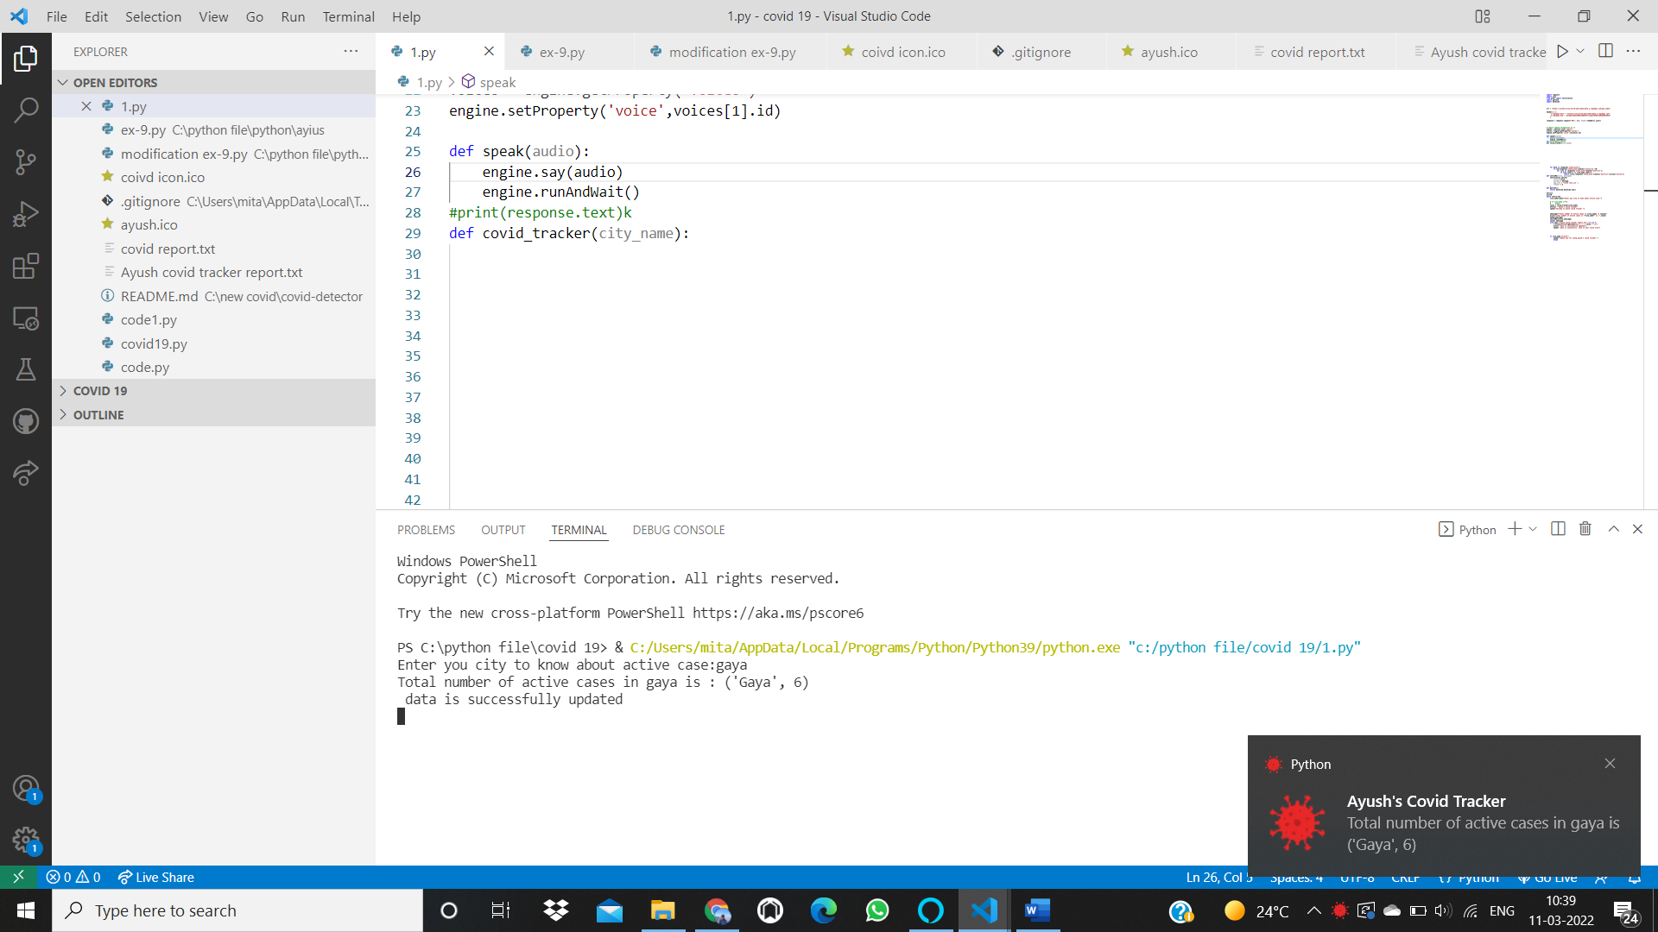

Fig 1:-VIEW OF TRACKING MODULE

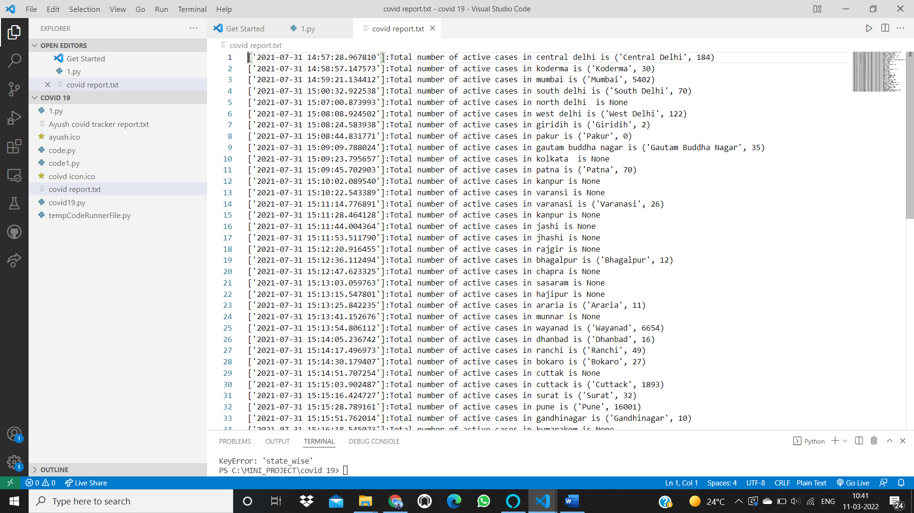

Fig 2:-txt file save for tracking module

DETECTION MODULE:- detection it will predict the infection probability of person while using different ML parameter of data feature i.e symptoms of covid till now discovered .While entering the symptoms of person ml model used to predict the infection probability of person .This prediction is based on past data record of covid -19 infected person symptoms.

A team of doctors can sit down to find out the best model parameters.

A sample set of such parameters is as follows:

**ML Features**:

Average Fever - Continuous

Body Pain - 0/1 - Binary

Age - Discrete

Runny Nose

Difficulty breathing - Categorical: -1/0/1

Oxygen level range:-40-99

**Labels:**

Probability of Covid-19 Infection

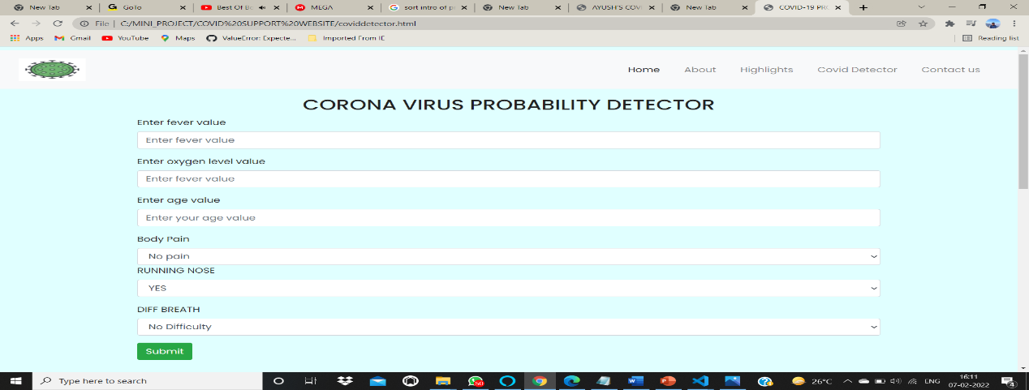

Fig 3:- detector module view

**CHAPTER 4**

**PROPOSED WORK AND SYSTEM DESIGN**

**4.1 Proposed Work**

DATA SETS USED OF MODULE FOR ANALYSIS AND DETECTING

TrackingDataset

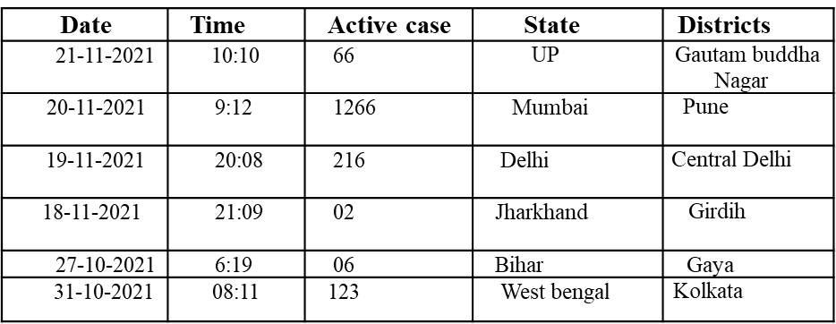

Fig 4:- data set of tracking module

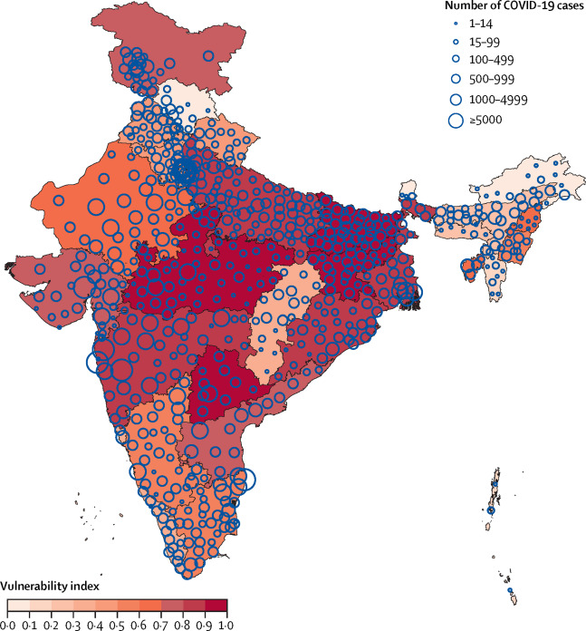

DETECTING DATASET:-

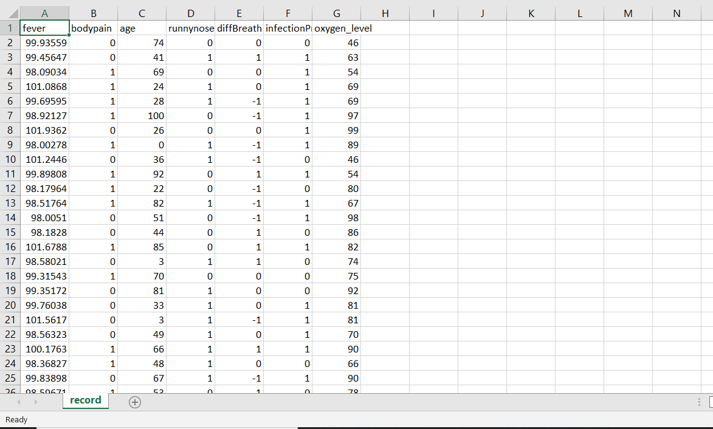

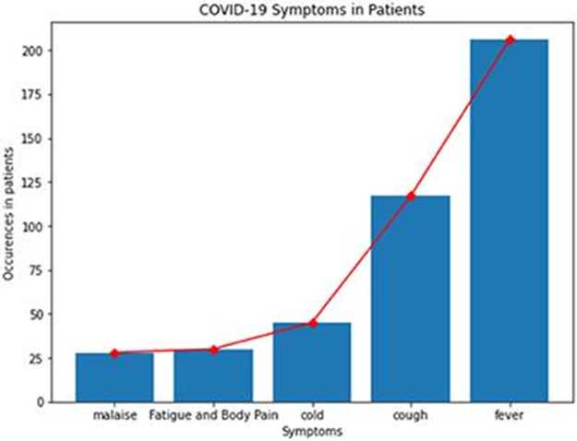

Fig 5:-dataset of detection module

.

**4.2 System Design**

4.2.1 Functional Specification of System

* This project is basically based on python Language and for web hosting we uses HTML, CSS and java script.
* In our first model i.e., Tracking model in which we used different types of module of python such as Request module for collecting data through API keys which is provided by Ministry of Health Department.
* We use Json module for calling the URL, Datetime module for saving the active cases data with date and time in COVID file and Small notification bar by Player module.
* In our second model i.e., Detector model we made Machine learning for COVID infection prediction. We used logistic regression method for prediction.
* We collected all our data from ministry website and created a CSV file which contains column such as Body pain, diff breath,person’s age, fever running nose, etc..
* We uses Pandas module of python which helps to read this CSV file and also uses
* The Numpy module to create array for better implementation of ML model.
* After all this process we host it on the Websites with the help of web developing. Flask module is used here for web developing and HTML, CSS, JS for creating a websites and designing.
* Web hosting is done through service provider Heroku platform and with the help of Gits and Github
* Website helps in fetecting the information from WHO also because it’s link with who website and direct linking with aroyga sethu app .

**WEB SITE VIEW:-**

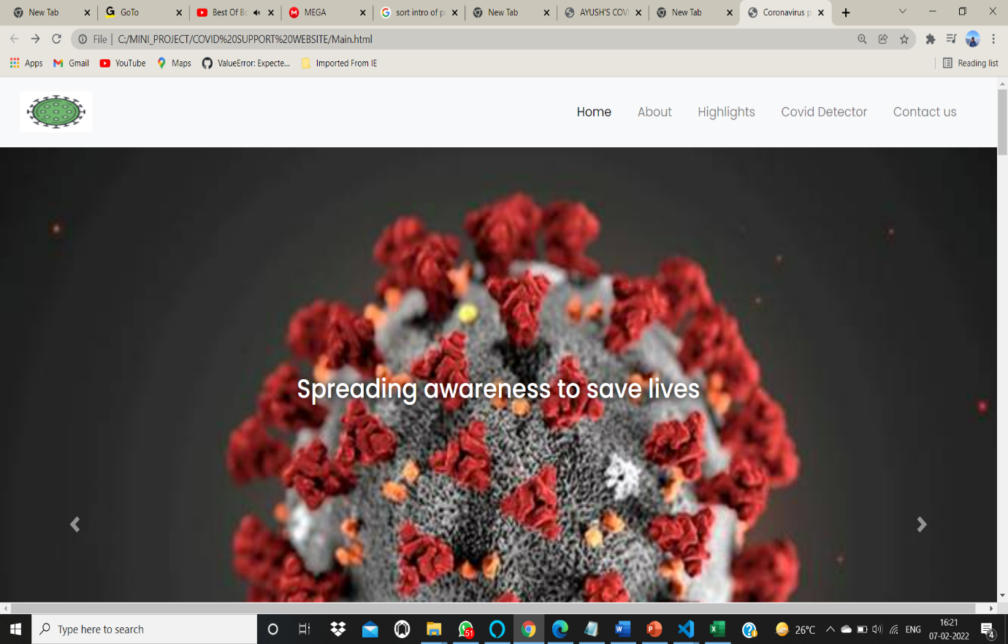

Fig 6:- website 1st view

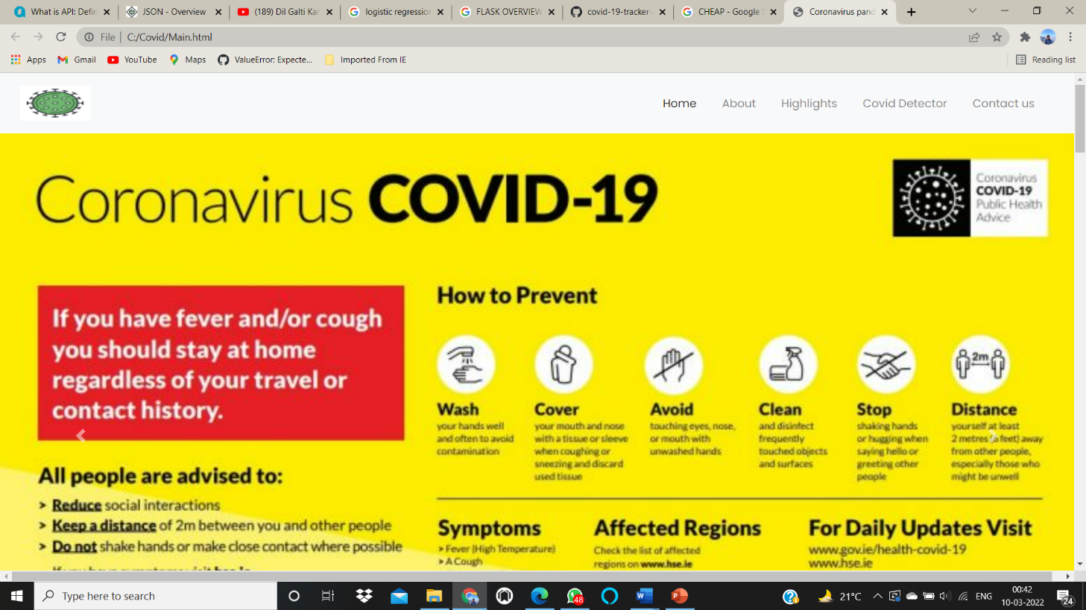

Fig 7:-website view related to information

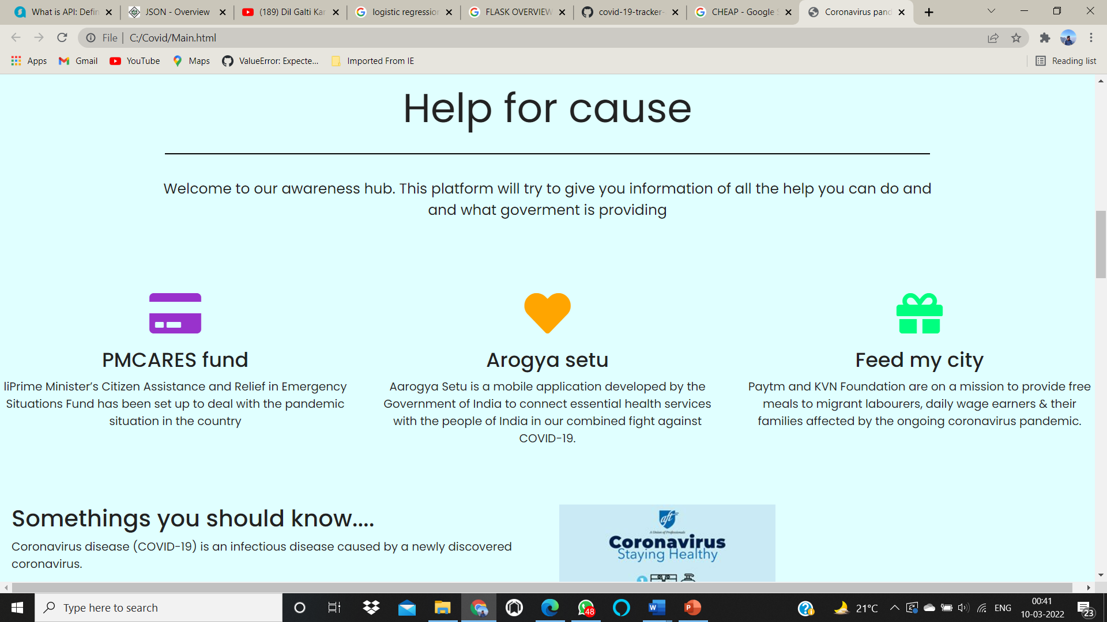

Fig 8:-website view for contact details

*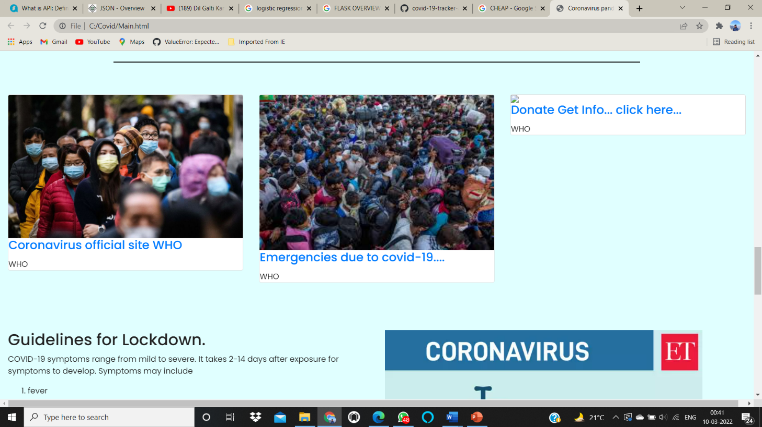\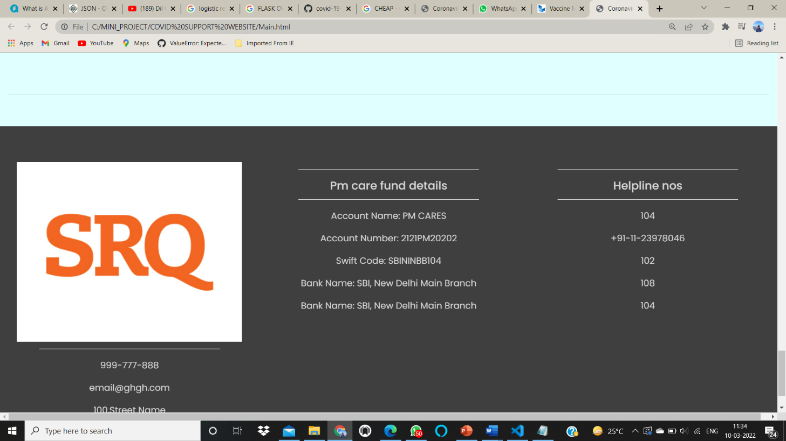*

Fig 9:- website view for articles

**CHAPTER 5**

**IMPLEMENTATION**

**5.1 HARDWARE AND SOFTWARE REQUIREMENT SPECIFICATION**

**Server Side:**

**Hardware**

• Processor : Intel core processor 2 GHz

• RAM : 2 GB RAM

• Hard Disk : 80 GB HDD

• Monitor : Compatible Printing Device

• Keyboard : Any Keyboard

• printe

**Software**

* Vs code
* Jupyter notebook
* Python 3.8
* HTML
* CSS
* JS
* FLASK
* HEROKU

**5.2 Dataset Description**

**Table: Application**

**TRACKING DATA SET**

|  |  |  |
| --- | --- | --- |
| **Field** | **Data Type** | **Size** |
| DISTRICT NAME | CHAR | 100 |
| ACTIVE CASE | INT | 255 |
| DATE | varchar | 255 |
| TIME | varchar | 255 |

**Table:DETECTION**

|  |  |  |
| --- | --- | --- |
| **Field** | **Data Type** | **RANGE** |
| Fever | FLOAT | 99-106 |
| AGE | INT | 1-100 |
| OXYGEN LEVEL | INT | 40-99 |
| RUNNY NOSE | INT | 0-1(0-NO,1-YES) |
| DIFF BREATH | INT | -1,0,1(-1 for no difficult,0-little ,1-server |
| BODY PAIN | INT | 0,1(0-NO,1-YES) |
|  |  |  |

**SOURCE CODE:-**

**TRACKING MODULE:-**

import request

import json

from plyer import notification

import pyttsx3

import datetime

url = "https://corona-virus-world-and-india-data.p.rapidapi.com/api_india"

headers = {

    'x-rapidapi-host': "corona-virus-world-and-india-data.p.rapidapi.com",

    'x-rapidapi-key': "a2c8b2c3b2msh902c040b7877cc3p147d29jsn502e8e0c69c8"

    }

response = requests.request("GET", url, headers=headers).json()

# import speech_recognition as sr

engine = pyttsx3.init('sapi5')

voices = engine.getProperty('voices')

engine.setProperty('voice',voices[1].id)

def speak(audio):

    engine.say(audio)

    engine.runAndWait()

#print(response.text)k

def covid_tracker(city_name):

    for each in response['state_wise']:

        if int(response['state_wise'][each]['active']) !=0:

            for city in response['state_wise'][each]['district']:

                if city.lower() == city_name.lower():

                    return (city,response['state_wise'][each]['district'][city]['active'])

def notifyMe(title, message):

    notification.notify(

        title = title,

        message = message,

        app_icon = "coivd icon.ico ",

        timeout = 6

    )

def gettime():

    return datetime.datetime.now()

Entry=1

exit=0

while (Entry!=0):

    city_name=input("Enter you city to know about active case:")

    # if city_name =="0":

    #     break

    cases = covid_tracker(city_name)

    ntitle= " Ayush's Covid Tracker"

    speak("welcome to ayush covid Tracker ")

    nmessage=f"Total number of active cases in {city_name} is {cases}"

    print("Total number of active cases in "+city_name+" is :",cases)

    speak(nmessage)

    notifyMe(ntitle,nmessage)

    value= nmessage

    with open ("Ayush covid tracker report.txt","a") as f:

        f.write(str([str(gettime())]) + ":" + value + "\n")

        print(" data is successfully updated")

        speak(" data is sucessfully  save in your covid file")

    if city_name =="exit":

        speak("thanks you for using ayush's covid tracker" )

        break

**DETECTOR MODULE:-**

**ML IMPLEMENTATION CODE:-**

import pandas as pd

import numpy as np

from sklearn.model_selection import train_test_split

from sklearn.linear_model import LogisticRegression

import pickle

if __name__=="__main__":

    #REading of data

    df=pd.read_csv('record.csv')

    X=df.drop(['infectionProp'],axis='columns')

    Y=df['infectionProp']

    X_train,X_test,Y_train,Y_test=train_test_split(X,Y,test_size=0.3)

    X_train=X_train.to_numpy()

    X_test=X_test.to_numpy()

    Y_train=Y_train.to_numpy()

    Y_test=Y_test.to_numpy()

    model=LogisticRegression()

    model.fit(X_train,Y_train)

    # open a file, where you ant to store the data

    file = open('model.pkl', 'wb')

    # dump information to that file

    pickle.dump(model, file)

    file.close()

**MAIN.PY:-**

from flask import Flask, render_template,request

import pickle

app = Flask(__name__,template_folder='template')

with open('model.pkl','rb') as f:

    model=pickle.load(f)

@app.route("/",methods=["GET","POST"])

def hello_world():

    if request.method=="POST":

        myDict=request.form

        fever= int(myDict['fever'])

        bodypain=int(myDict['bodypain'])

        age=int(myDict['age'])

        runnynose=int(myDict['runnynose'])

        diffBreath=int(myDict['diffBreath'])

        oxygen_level=int(myDict['oxygen_level'])

    #code for interference

        input_features=[ fever, bodypain,age,runnynose,diffBreath,oxygen_level]

        infoprob= model.predict_proba([input_features])[0][1]

        print(infoprob)

        return render_template('show.html',inf=round(infoprob*100))

    #return "<p>Hello World!!</p> " + str(infoprob)

return render_template('index.html')

if __name__ == "__main__":

    app.run(debug=True)

**HTML TEMPLATE:-**

<!DOCTYPE html>

<html lang="en">

<head>

    <meta charset="utf-8">

    <meta name="viewport" content="width=device-width, initial-scale=1">

    <title>Coronavirus pandemic</title>

    <link rel="stylesheet" href="https://maxcdn.bootstrapcdn.com/bootstrap/4.0.0/css/bootstrap.min.css">

    <script src="https://ajax.googleapis.com/ajax/libs/jquery/3.3.1/jquery.min.js"></script>

    <script src="https://cdnjs.cloudflare.com/ajax/libs/popper.js/1.12.9/umd/popper.min.js"></script>

    <script src="https://maxcdn.bootstrapcdn.com/bootstrap/4.0.0/js/bootstrap.min.js"></script>

    <link rel="stylesheet" href="https://use.fontawesome.com/releases/v5.7.0/css/all.css" integrity="sha384-lZN37f5QGtY3VHgisS14W3ExzMWZxybE1SJSEsQp9S+oqd12jhcu+A56Ebc1zFSJ" crossorigin="anonymous">

    <link href="  sstyle.css" rel="stylesheet">

</head>

<body>

<!-- Navigation -->

<nav class="navbar navbar-expand-md navbar-light bg-light navbar-inverse sticky-top">

        <div class="container-fluid">

            <a class="navbar-brand" href="#"><img src="icon.png" width="100" height="50"></a>

            <button class="navbar-toggler" type="button" data-toggle="collapse" data-target="#mainNav">

                <span class="navbar-toggler-icon"></span>

            </button>

            <div class="collapse navbar-collapse" id="mainNav">

                <ul class="navbar-nav ml-auto">

                    <li class="nav-item">

                    <a class="nav-link active" href="Main.html">Home</a>

                    </li>

                      <li class="nav-item">

                    <a class="nav-link " href="#About">About</a>

                    </li>

                        <li class="nav-item">

                    <a class="nav-link " href="#Highlights">Highlights</a>

                    </li>

                        <li class="nav-item">

                    <a class="nav-link " href="coviddetector.html">Covid Detector</a>

                    <!-- <li><a href=" nav-link">#Detector</a></li>

                    </li> -->

                        <li class="nav-item">

                    <a class="nav-link " href="#Contact">Contact us</a>

                    </li>

                </ul>

            </div>

        </div>

    </nav>

<!--- Image Slider -->

<div id="slide" class="carousel slide" data-ride="carousel">

    <ul class="carousel-indicators">

        <li data-target="#slides" data-slide-to="0" class="active"></li>

 <li data-target="#slides" data-slide-to="1" ></li>

 <li data-target="#slides" data-slide-to="2" ></li>

    </ul>

    <div class="carousel-inner">

        <div class="carousel-item active">

        <img src ="image1.jpg">

            <div class="carousel-caption">

                <h3>Spreading awareness to save lives</h3>

            </div>

    </div>

         <div class="carousel-item ">

        <img src ="image2.jpg">

    </div>

         <div class="carousel-item">

        <img src = "image3.jpeg">

        </div>

    </div>

     <a class="carousel-control-prev" href="#slides" role="button" data-slide="prev">

    <span class="carousel-control-prev-icon" aria-hidden="true"></span>

    <span class="sr-only">Previous</span>

  </a>

  <a class="carousel-control-next" href="#slides" role="button" data-slide="next">

    <span class="carousel-control-next-icon" aria-hidden="true"></span>

    <span class="sr-only">Next</span>

  </a>

    </div>

<!--- Jumbotron -->

<div class="container-fluid">

    <div class="row jumbotron">

    <div class="col-xs-12 col-sm-12 col-md-9 col-lg-9 col-xl-10">

        <p class="lead"> This will allow us to understand the rule which are imposed by the goverment of the pandemic and how we can help each other in this situation in our country.</p>

        </div>

        <div class="col-xs-12 col-sm-12 col-md-3 col-lg-3 col-xl-2">

            <a href="https://play.google.com/store/apps/details?id=nic.goi.aarogyasetu&hl=en_IN"><button type="button" class="btn btn-outline-secondary btn-lg">Arogya Setu</button></a>

    </div>

    </div>

    </div>

<!--- Welcome Section -->

<div class="container-fluid padding">

    <div class="row welcome text-center">

        <div class="col-12">

            <h1 class="display-4">Help for cause</h1>

        </div>

        <hr>

        <div class="col-12">

            <p class="lead">Welcome to our awareness hub. This platform will try to give you information of all the help you can do and and what goverment is providing</p>

        </div>

    </div>

    </div>

<!--- Three Column Section -->

<div class="container-fluid-padding">

    <div class="row text-center padding">

        <div class="col-xs-12 col-sm-6 col-md-4">

        <i class="fa fa-credit-card" aria-hidden="true"></i>

            <h3>PMCARES fund</h3>

            <p>liPrime Minister’s Citizen Assistance and Relief in Emergency Situations Fund has been set up to deal with the pandemic situation in the country</p>

        </div>

  <div class="col-xs-12 col-sm-6 col-md-4">

        <i class="fa fa-heart" aria-hidden="true"></i>

            <h3>Arogya setu</h3>

            <p> Aarogya Setu is a mobile application developed by the Government of India to connect essential health services with the people of India in our combined fight against COVID-19. </p>

        </div>

          <div class="col-xs-12 col-sm-6 col-md-4">

       <i class="fas fa-gift"aria-hidden="true"></i>

            <h3>Feed my city</h3>

            <p>Paytm and KVN Foundation are on a mission to provide free meals to migrant labourers, daily wage earners & their families affected by the ongoing coronavirus pandemic.</p>

        </div>

    </div>

    </div>

<!--- Two Column Section -->

<div class="container-fluid padding">

    <div class="row padding">

        <div class="col-lg-6" id="About">

            <h2>Somethings you should know....</h2>

                <p>Coronavirus disease (COVID-19) is an infectious disease caused by a newly discovered coronavirus.</p>

                <p> Most people infected with the COVID-19 virus will experience mild to moderate respiratory illness and recover without requiring special treatment.  </p>

                <p>The best way to prevent and slow down transmission is be well informed about the COVID-19 virus, the disease it causes and how it spreads. </p>

                <br>

                <a href="https://www.who.int/health-topics/coronavirus#tab=tab_1" class="btn btn-primary">Learn more</a>

                   </div>

  <div class="col-lg-6">

      <img src="corona76.jpeg" class="img=fluid">

                </div>

           </div>

       </div>

              <hr class="my-4">

<!--- Fixed background -->

<figure>

    <div class="fixed-wrap">

        <div id="fixed">

        </div>

    </div>

    </figure>

<!--- Emoji Section -->

<button class="fun" data-toggle="collapse" data-target="#games">How can we be happy in such a time</button>

    <div id="games" class="collapse">

        <div class="container-fluid padding">

            <div class="row text-center">

                <div class="col-sm-6 col-md-3">

                    <img class="gif" src="giphy (1).gif">

                </div>

                   <div class="col-sm-6 col-md-3">

                    <img class="gif" src=" giphy (3).gif">

                </div>

                   <div class="col-sm-6 col-md-3">

                    <img class="gif" src=" giphy.gif">

                </div>

            <div class="col-sm-6 col-md-3">

                    <img class="gif" src=" giphy (2).gif">

                </div>

            </div>

        </div>

    </div>

<!---Watch the Highlights -->

<div class="container-fluid padding">

    <div class="row welcome text-center">

        <div class="col-12">

            <h1 class="display-4" id="Highlights">Top Stories</h1>

        </div>

        <hr>

    </div>

    </div>

<!--- Cards -->

<div class="container-fluid padding">

    <div class="row padding">

        <div class="col-md-4">

        <div class="card">

                    <img class="card-img-top img-fluid" src=" card1.jpg">

                    <div class="card-block">

                      <h4 class="card-title">  <a href="https://www.who.int/health-topics/coronavirus#tab=tab_1.html" class="card-link"> Coronavirus official site WHO</a></h4>

                        <p class="card-text">WHO</p>

                    </div>

                </div>

            </div>

    <div class="col-md-4">

        <div class="card">

                    <img class="card-img-top img-fluid" src=" card2.jpg">

                    <div class="card-block">

                      <h4 class="card-title">  <a href="https://www.who.int/emergencies/diseases/novel-coronavirus-2019/events-as-they-happen" class="card-link"> Emergencies due to covid-19....</a></h4>

                        <p class="card-text">WHO</p>

                    </div>

                </div>

            </div>

          <div class="col-md-4">

        <div class="card">

                    <img class="card-img-top img-fluid" src=" /card3.jpg">

                    <div class="card-block">

                      <h4 class="card-title">  <a href="https://www.who.int/emergencies/diseases/novel-coronavirus-2019.html" class="card-link"> Donate Get Info... click here...</a></h4>

                        <p class="card-text">WHO</p>

                    </div>

                </div>

            </div>

    </div>

    </div>

<!--- Two Column Section -->

<div class="container-fluid padding">

    <div class="row padding">

        <div class="col-lg-6" id="Health">

            <h2>Guidelines for Lockdown.</h2>

                <p>COVID-19 symptoms range from mild to severe. It takes 2-14 days after exposure for symptoms to develop.

Symptoms may include

<ol>

    <li>fever</li>

    <li>cough</li>

    <li>diff breath</li>

    <li>body pain</li>

        </ol>

Those with weakened immune systems may develop more serious symptoms, like pneumonia or bronchitis. You may never develop symptoms after being exposed to COVID-19. So far, most confirmed cases are in adults, but some children have been infected. There is no evidence that children are at greater risk for getting the virus.

        </p>

                <p>All person going out for any essential purpose must wear a mask.</p>

                   </div>

  <div class="col-lg-6">

      <img src=" lock.jpeg" class="img-fluid">

                </div>

           </div>

    <hr class="my-4">

       </div>

<!--- Connect -->

<div class="container-fluid padding">

    <div class="row text-center padding">

        <div class="col-12">

            <h2>Connect with us</h2>

        </div>

        <div class="col-12 social padding">

            <a href="#"><i class="fab fa-facebook"></i></a>

              <a href="#"><i class="fab fa-twitter"></i></a>

              <a href="#"><i class="fab fa-instagram"></i></a>

              <a href="#"><i class="fab fa-google-plus-g"></i></a>

        </div>

    </div>

      <hr class="my-4">

    </div>

<!--- Footer -->

<footer id="Contact">

    <div class="container-fluid padding">

        <div class="row text-center">

            <div class="col-md-4">

                <img src=" 12.png.jpg">

                <hr class="light">

                <p>999-777-888</p>

       <p>email@ghgh.com</p>

       <p>100,Street Name</p>

       <p>State,987779</p>

            </div>

      <div class="col-md-4">

                <hr class="light">

          <h5>Pm care fund details</h5>

                <hr class="light">

                <p>Account Name: PM CARES </p>

       <p>Account Number: 2121PM20202</p>

       <p>Swift Code: SBININBB104</p>

       <p>Bank Name: SBI, New Delhi Main Branch</p>

               <p>Bank Name: SBI, New Delhi Main Branch</p>

            </div>

             <div class="col-md-4">

                <hr class="light">

          <h5>Helpline nos</h5>

                <hr class="light">

                <p>104</p>

       <p>+91-11-23978046</p>

       <p>102</p>

       <p>108</p>

               <p>104</p>

            </div>

        </div>

    </div>

            </footer>

</body>

</html>

**CHAPTER 6**

**RESULT AND DEMONSTRATION**

**For TRACKING MODULE :-**

IT will fetching the live data of active case in every district wise and it will help to analysis the graph of active cases per day in district .DATA will save with date and time ,so it’s helps to analysis the exact figure of active in every moment .

['2021-08-01 20:03:19.812665']:Total number of active cases in central delhi is ('Central Delhi', 184)

['2021-08-01 20:03:34.238314']:Total number of active cases in koderma is ('Koderma', 29)

['2021-08-01 20:03:45.475957']:Total number of active cases in mumbai is ('Mumbai', 5269)

['2021-08-01 20:03:58.180997']:Total number of active cases in south delhi is ('South Delhi', 70)

['2021-08-01 20:04:10.816833']:Total number of active cases in west delhi is ('West Delhi', 122)

['2021-08-01 20:04:20.881867']:Total number of active cases in giridih is ('Giridih', 2)

['2021-08-01 20:04:41.477308']:Total number of active cases in gautam buddha nagar is ('Gautam Buddha Nagar', 35)

['2021-08-01 20:04:53.976142']:Total number of active cases in kolkata is ('Kolkata', 716)

['2021-08-01 20:05:05.286776']:Total number of active cases in patna is ('Patna', 66)

['2021-08-01 20:05:19.015824']:Total number of active cases in varanasi is ('Varanasi', 26)

['2021-08-01 20:05:37.138070']:Total number of active cases in wayanad is ('Wayanad', 6777)

['2021-08-01 20:05:56.913321']:Total number of active cases in dhanbad is ('Dhanbad', 17)

['2021-08-01 20:06:06.430160']:Total number of active cases in ranchi is ('Ranchi', 49)

['2021-08-01 20:06:15.284797']:Total number of active cases in bokaro is ('Bokaro', 30)

['2021-08-01 20:06:26.319041']:Total number of active cases in cuttack is ('Cuttack', 1844)

['2021-08-01 20:06:36.419483']:Total number of active cases in surat is ('Surat', 29)

['2021-08-01 20:06:47.599516']:Total number of active cases in pune is ('Pune', 15674)

['2021-08-01 20:07:08.593768']:Total number of active cases in visakhapatnam is ('Visakhapatnam', 828)

['2021-08-01 20:07:19.139208']:Total number of active cases in gaya is ('Gaya', 2)

['2021-08-01 20:07:48.581680']:Total number of active cases in bareilly is ('Bareilly', 15)

['2021-08-01 20:08:00.142319']:Total number of active cases in rampur is ('Rampur', 7)

['2021-08-01 20:08:10.665951']:Total number of active cases in raipur is ('Raipur', 115)

['2021-08-01 20:09:22.740505']:Total number of active cases in gwalior is ('Gwalior', 30)

['2021-08-04 17:21:58.988541']:Total number of active cases in south delhi is ('South Delhi', 70)

**FOR DETECTION MODULE:-**

* IT will predict the % probability of infection of person by filling the symptoms of machine learning parameters if it is more than 60% then they will go for testing and after positive result takes all proper precaution. it’s accuracy is 70% as per record excel file collected from the society

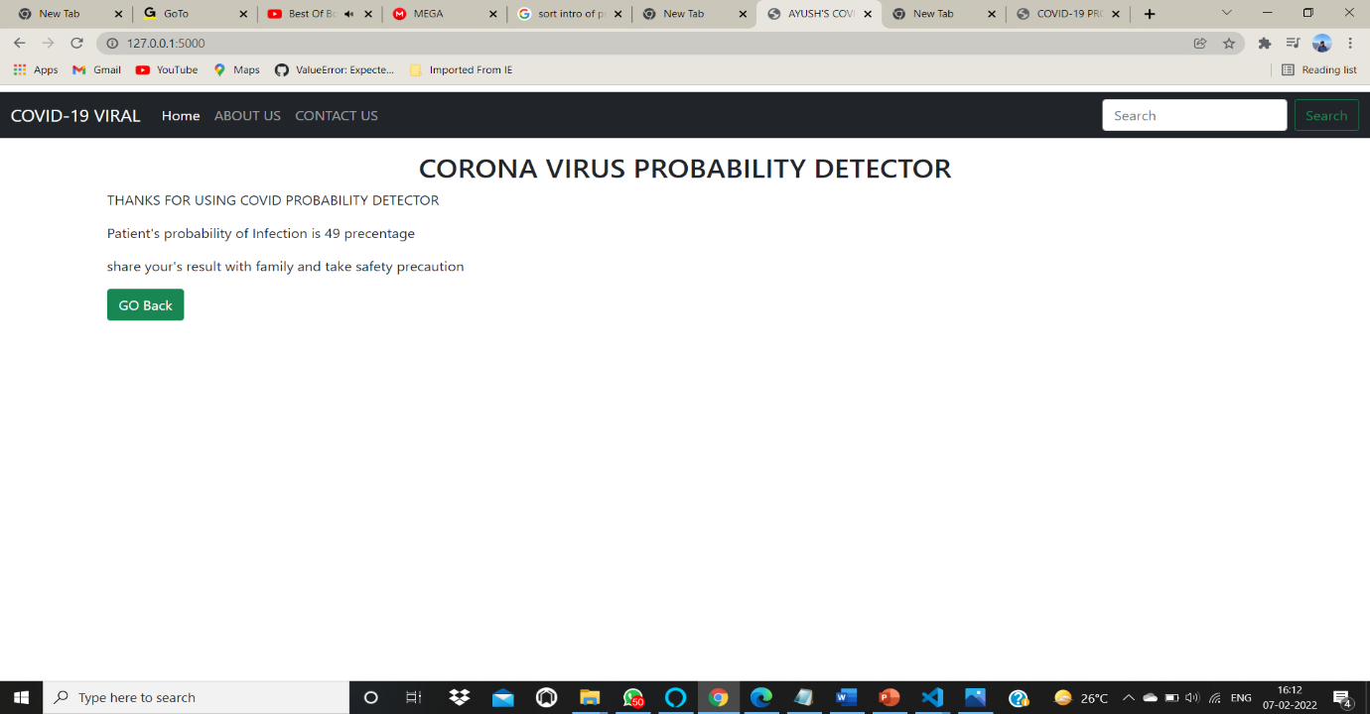

Fig 10:- Result View for detection module

**CHAPTER 7**

**CONTRIBUTION OF PROJECT TO THE SOCIETY**

**7.1 Objective and Relevance of Project**

• This website helps people for information related to covid and follow the instruction to protect themselves from covid.

• IT Will works on three major factor tracking ,detecting ,testing and this helps us people to protect from covid-19 virus .

•ALL proper precaution and instruction given in this web site which helps people for follow and all contact details was also provided in this web site

.

The idea of project to stop the spread of covid virus .In this project there is two module 1st one is for tracking and 2nd is used for detection .For using this idea we have to control the spread of corona virus by using tracking ,detection,testing and one day world is free from covid -19.

**CHAPTER 8**

**CONCLUSION, LIMITATION AND FUTURE SCOPE**

**8.1 Conclusion**

* This website helps people for detecting it’s covid infection and it’s accuracy is 70% as per record excel file collected from the society.
* For tracking we get conculed the data as per our level so that peoples know idea active cases of data of every district wise.
* Website helps people of information related to covid and all the instruction is provided in covid website.

**8.2 Limitation**

**User side:**

1.IT’s accuracy is 70% right which is not upto mark

2. less amount data is used in excel sheet.

3. website is extent more and more information are used in website.

**8.3 Future Scope**

* We can make multiple ML models in future like this.
* This model can be used in detection of covid and it’s variants and other viruses in future as well.

**REFERENCES**

**SOURCE CODE:-https://github.com/ayushranjan2806**

**PYTTSX3 :-https://dev.to/divshekhar/text-to-speech-in-python-tts-using-pyttsx3-4095**

**API:-https://www.mulesoft.com/resources/api/what-is-an-api**

**PLYER:-https://www.geeksforgeeks.org/python-desktop-notifier-using-plyer-module/**

**PANDAS:-https://pandas.pydata.org/**

**NUMPY:-https://www.w3schools.com/python/numpy/numpy_intro.asp**

**LOGISTIC REGRESSION:-https://scikit-learn.org/stable/modules/generated/sklearn.linear_model.LogisticRegression.html**

**FLASK:-https://flask.palletsprojects.com/en/2.0.x/**

**HTML CSS JS :-https://www.w3schools.com/jsref/**

